Optional submission variation:

1. Put the images on your poster and number them clearly. You’ll turn it on due date.
2. Type your identification and explanation of technique in a word document. Upload the doc to Canvas at due date.

Poster sample Word Document in Canvas

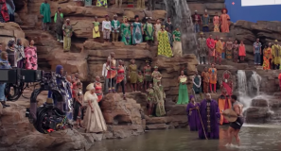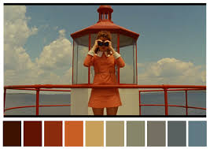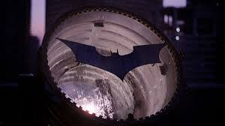

1. Long shot: Taken from *Black Panther*, the scene establishes the importance of community in this society. Whether to witness a battle or celebrate a victory, the society experiences life’s trials and triumphs together. The long shot helps to position the people of Wakanda as spectators, here cheering on T’Challa’s character and sets up an epic battle.

2. Low angle: In this scene from *Hocus Pocus*, three resurrected witches are depicted as predatory. They are above the child, whom they are hunting so they can steal her life force. They appear larger (especially to the child they hover over), and so appear frightening.

3. Close shot: with explanation

4. High key lighting: with explanation

And so on!

